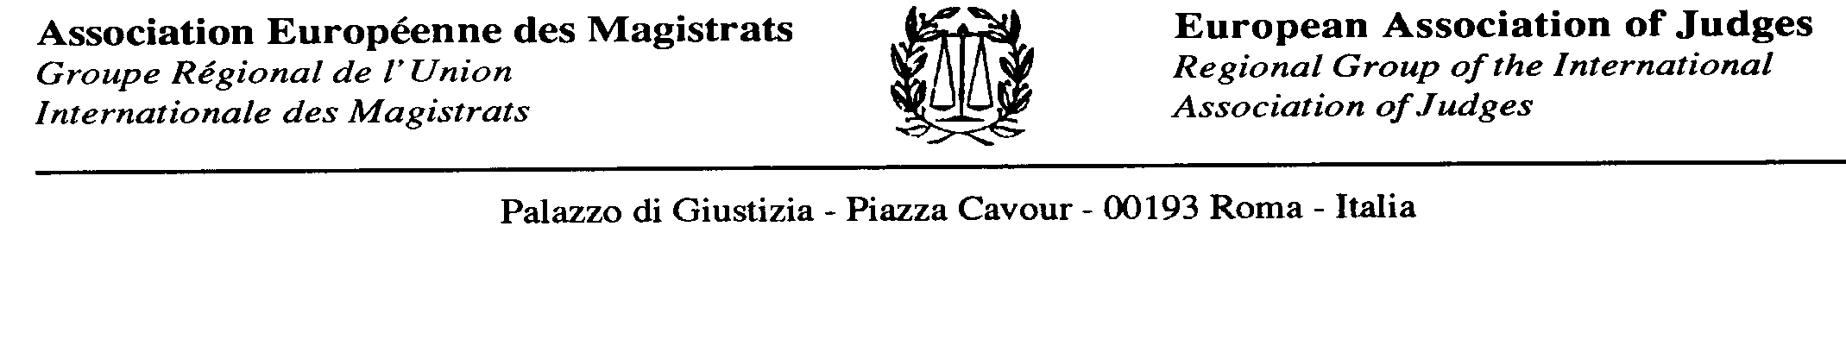
Press release
Contact : PRESIDENT DE L’A.E.M.  M. Christophe REGNARD  Président de l’Association Européenne des Magistrats  Bureau :  Tél. : +33 (0)1 43 54 21 26  +33 (0)6 76 56 99 56  C/o USM : 33 rue du Four, 75006 Paris  Email : Contact@union-syndicale-magistrats.org  Email : chreg67@yahoo.fr | Embargo 29th May 2015

THE EUROPEAN ASSOCIATION OF JUDGES DEMANDS THE IMMEDIATE RELEASE FROM detention OF TWO TURKISH JUDGES

The European Association of Judges demands the immediate release of two judges, Metin Özcelik and Mustafa Baser, both currently held in detention in Turkey. The two turkish judges were arrested in Istanbul on the 30th April 2015, after having ordered the release from pre-trial detention of police officers and journalists.

During its Conference held in Gdansk on 16th May 2015, the European Association of Judges dealt with the problems of justice in Turkey. Special focus was given to the arrest and detention of the two Turkish judges Metin Özcelik and Mustafa Baser on the 30th April 2015 in Istanbul.

In its resolution, the European Association of Judges stated the following:
- The arrest and detention proceeded on the purported ground that the judges had ordered the release of an alleged suspect.
- Any attempt to undermine the freedom of a judge to establish facts and apply the law in a particular case constitutes a clear breach of principle of judicial independence.
- EAJ condemns the arrest and detention of any judge on the basis of a decision taken in the exercise of the judge’s judicial functions and calls for the immediate release of the judges Metin Özcelik and Mustafa Baser.

On 25th April 2015, Metin Özcelik (Istanbul 29th Court of First Instance) and Mustafa Baser (Istanbul 32nd Court of First Instance) ordered the release of police officers and journalists, who had spent six months in provisional detention. The state prosecutor in charge refused to sign the release order, referring to an instruction he had received from the Deputy Attorney general. After a critical article about the release order in a newspaper, the former Minister of Justice expressed negative views on the decision taken by Metin Özcelik and Mustafa Baser to release the prisoners. During a press conference, the turkish President Erdogan blamed the turkish High Council of Judges and Prosecutors (HCPJ) for not having intervened. The President of the competent Commission of the HCPJ apologized for the belated intervention and suspended the two judges. A court, not competent in this matter, declared the orders of release invalid. A state prosecutor opened an investigation against the two judges. They were arrested on the basis of belonging to the same terrorist organisation, as the persons for whom they had ordered the release.

The European Association of Judges is a regional organization within the International Association of Judges. Its members come from 44 different countries. Their objectives include strengthening and supporting the rule of law as well as judicial independence and impartiality within the European scope and in all member states.

Further information:
- EAJ RESOLUTION ON THE SITUATION OF THE JUDICIARY IN TURKEY: http://www.iaj-uim.org/iuw/wp-content/uploads/2015/05/EAJ-resolution-on-Turkey-may-2015.pdf
- Background information on the case of the two judges Metin Özcelik und Mustafa Baser: http://www.iaj-uim.org/iuw/wp-content/uploads/2015/05/informative-report-arrest-and-detention-turkish-judges.pdf
- Information about the European Association of Judges: http://www.iaj-uim.org/regional-groups/

